Proforma - 1

Student Course Evaluation Questionnaire  (To be filled by each Student at the time of Course Completion) | 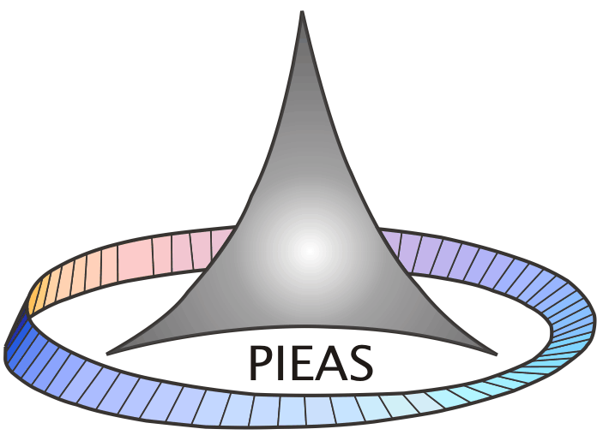
Department _______________________ ____Course No _________________________
Course Title __________________________Teacher Name:_______________________
Year of Study _______________________ Semester / Term ______________________
Please give us your views so that Course quality can be improved. You are encouraged to be frank and constructive in your comments

5: Strongly  Agree | 4: Agree | 2: Uncertain | 2: Disagree | 1: Strongly  Disagree

CORE QUESTIONS
Course Content and Organization | Marks
1. The course objectives were clear
2. The Course workload was manageable
3. The Course was well organized (e.g. timely access to materials, notification of changes, etc.)

Student Contribution | Marks
5. Approximate level of your own attendance during the whole Course
5: > 81%, 4: >60% 3: 41% , 2: >22% 1: less than 20%
6. I participated actively in the Course
7. I think I have made progress in this Course

Learning Environment and Teaching Methods | Marks
9. I think the Course was well structured to achieve the learning outcomes (there was a good balance of lectures, tutorials, practical etc.)
10. The learning and teaching methods encouraged participation.
11. The overall environment in the class was conducive to learning.
12. Classrooms were satisfactory

Learning Resources | Marks
14. Learning materials (Lesson Plans, Course Notes etc.) were relevant and useful.
15. Recommended reading Books etc. were relevant and appropriate
16. The provision of learning resources in the library was adequate and appropriate
17. The provision of learning resources on the Web was adequate and appropriate ( if relevant)

Quality of Delivery | Marks
19. The Course stimulated my interest and thought on the subject area
20. The pace of the Course was appropriate
21. Ideas and concepts were presented clearly

Assessment | Marks
23. The method of assessment were reasonable
24. Feedback on assessment was timely
25. Feedback on assessment was helpful

Additional Core Questions
Instructor / Teaching Assistant Evaluation | Marks
27. I understood the lectures
28. The material was well organized and presented
29. The instructor was responsive to student needs and problems
30. Had the instructor been regular throughout the course?

Tutorial | Marks
30. The material in the tutorials was useful
31. I was happy with the amount of work needed for tutorials
32. The tutor dealt effectively with my problems

Practical | Marks
33. The material in the practicals was useful
34. The demonstrators dealt effectively with my problems.

Overall Evaluation
35.The best features of the Course were:

36.The Course could have been improved by:

Equal Opportunities Monitoring (Optional)
- The University does not tolerate discrimination on any irrelevant distinction (e.g. race, age, gender) and is committed to work with diversity in a wholly positive way. Please indicate below anything in relation to this Course which may run counter to this objective:

Demographic Information: (Optional)
38. Full/part time study: Full Time  Part Time 
39.Do you consider yourself to be disabled: Yes  No 
40. Domicile:
41.Gender: Male  Female 
42. Age Group: less than 22  22-29  over 29 
43. Campus: Distance Learning/ Collaborative 

THANK YOU

